# CS 340 README Ryan Stork

*Use this template to complete your README file. When completing the template, keep the headings as they are so that your document has a clear organization. Remove the italicized prompt text after you have completed each section for a polished final document.*

## About the Project/Project Title

*In this project, we are traversing through the Austin Animal Center Outcomes csv file in Python. This project connects Python with MongoDB. We are running the database thru MongoDB and the interface thru python.*

## Motivation

*This project exists, because you don’t have to use a command line prompt (shell) to work with MongoDB. You can create a program in Python that works with MongoDB to make interface easier with a user.*

## Getting Started

*To get a local project up and running, follow these simple steps:*

1. *Install mongoDB*
2. *Import the database from the Austin Animal Control Database into mongoDB name it AAC*
3. *Create a username and password thru which the user would have to connect thru*
4. *Install Anaconda, then install the Jupyter*
5. *Load the Project2Dashboard.ipynb into Jupyter*
6. *Make sure that Project1.py and Grazioso Salvare Logo are located in the same root directory as the Project2Dashboard.ipynb file.*
7. *Start Mongodb, as it must be running in the background.*
8. *Follow the Usage guide on the different functions.*

## Installation

*The tools that you need to use this script are as follows:*

*Download mongoDB:* [*https://www.mongodb.com/try/download/community*](https://www.mongodb.com/try/download/community)

*Download Anaconda:* [*https://www.anaconda.com/products/individual*](https://www.anaconda.com/products/individual)

*Thru Anaconda dashboard, you can download or launch the IDE of your choice.*

## Usage

### Opening Image

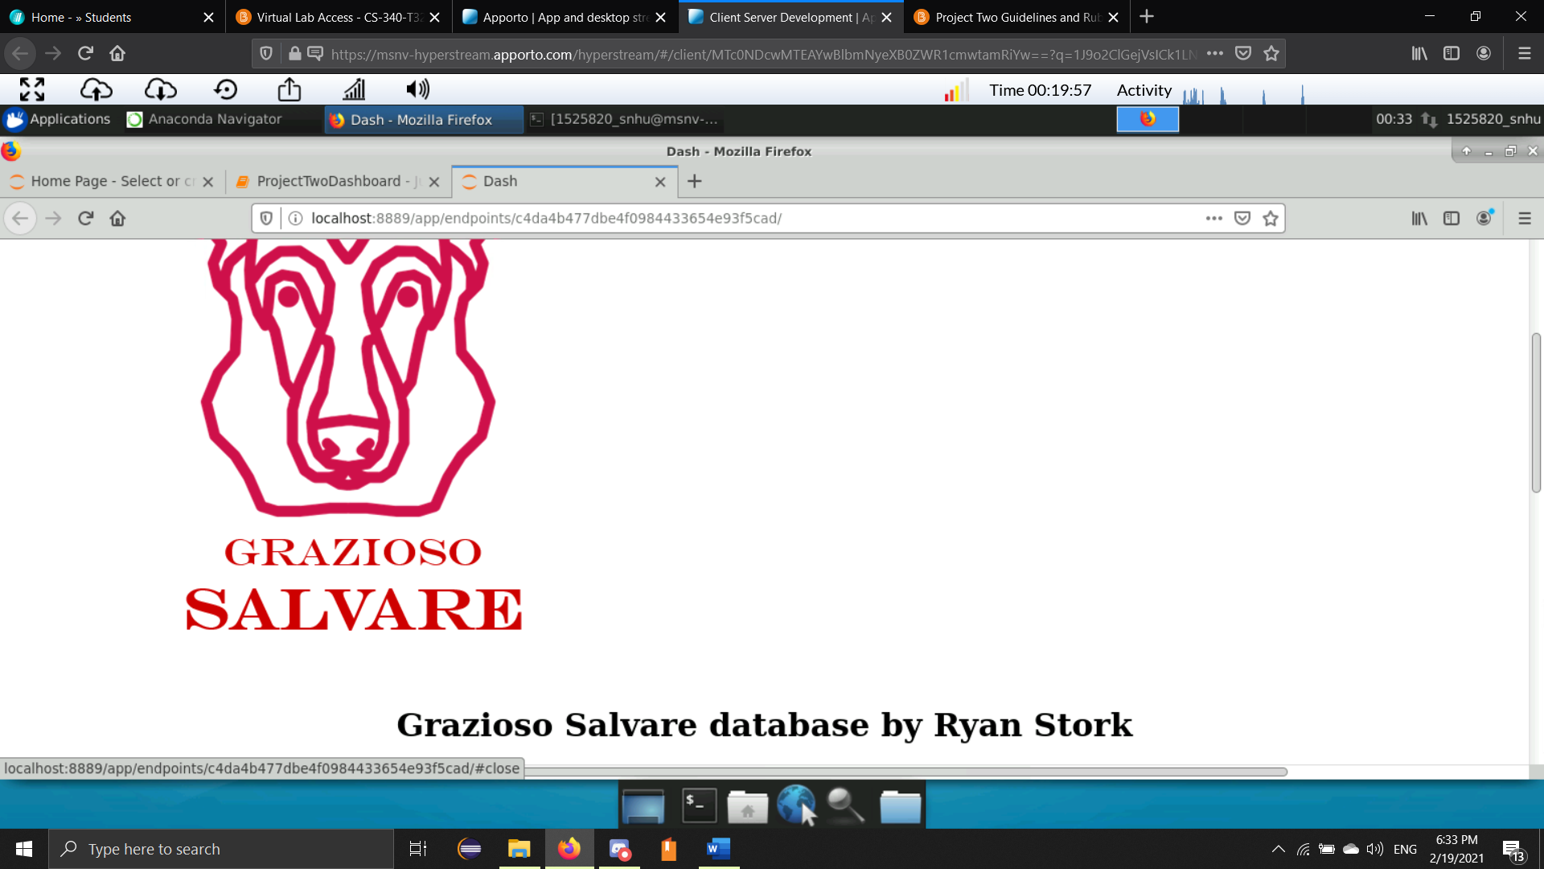

*When you run the application, it will display the Grazioso Salvare Logo along with the designer of the current project.*

### Filtering

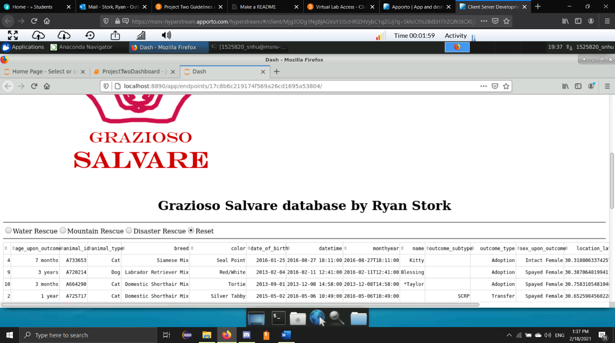*In this project, there are 4 different options to be used as a filter. These filters are Water Rescue, Mountain Rescue, and Disaster Rescue and Reset. The first 3 options filter specific types of dogs used in different that can handle specialized training for Rescue.*

*(Above) This is what the different options look like in the program. The default is on ‘Reset’. The database will show all animals in the Austin Animal Center Database.*

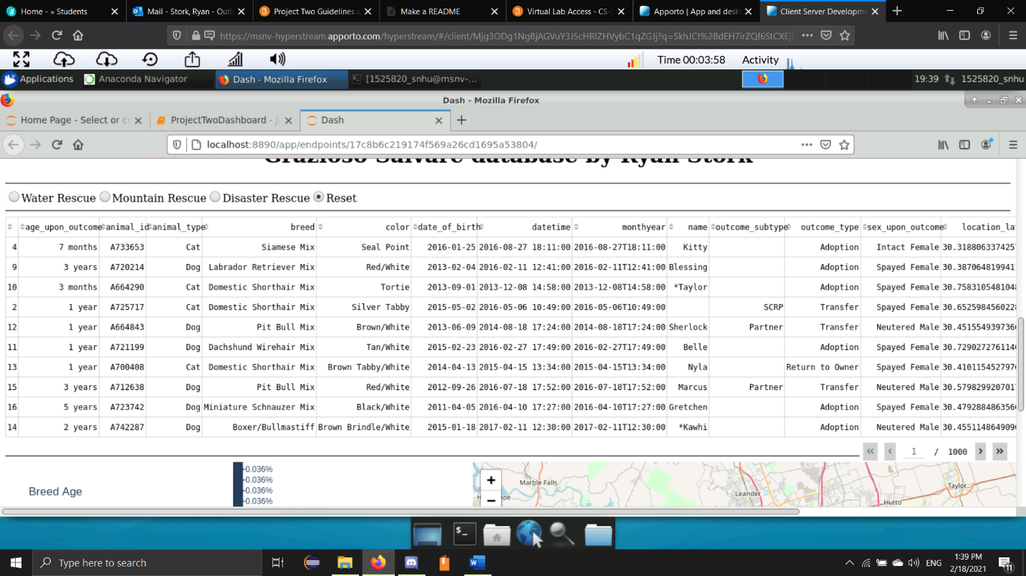

*(Above) This is the default table that loads into the application.*

### Widgets

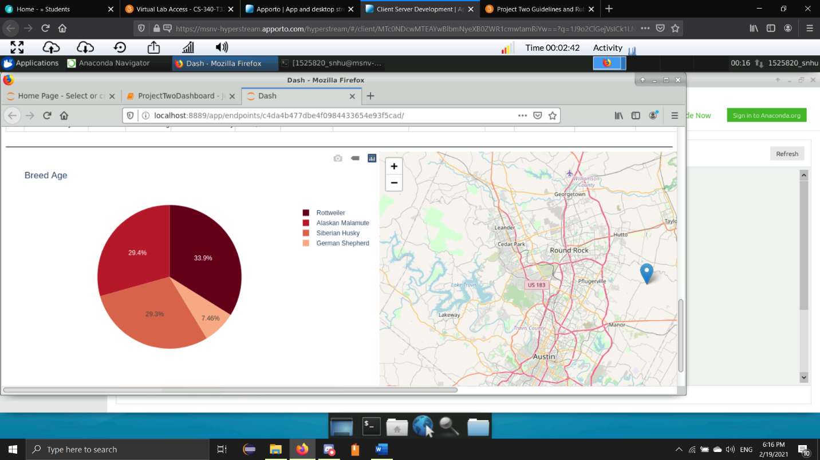

*(Above) There is also a pie chart that breaks down the different breeds based upon the current filter. The picture has the Mountain Rescue filter applied.*

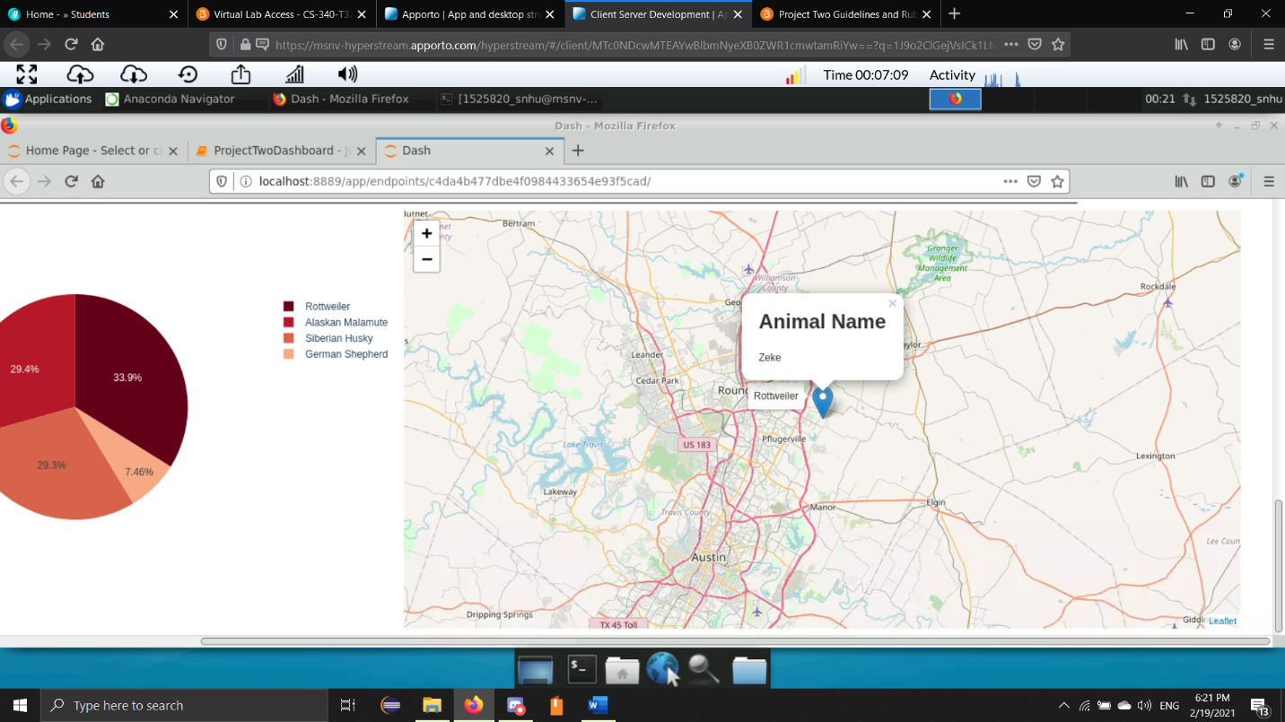

*(Above) There is a map with the coordinates of the current animal that is selected. To select an animal, just click on any cell in the row of the animal. The map will automatically update. If you hover your mouse on the map marker, the app will display the breed name. When it is clicked on, it will display the animal name.*

## Tools Used to Achieve Functionality

*MongoDB was used for the database of this program. It is a free NoSQL Database program that stores JSON-like documents. There is a Pymongo import that allows a user to create an interface in Python and connect to the database for user interaction. Python and Pymongo can create functions that interact with a MongoDB database to create, update, read and delete documents.*

*Our Python program also uses Dash. Dash creates a web interface that allows the program to be deployed on the internet and connect to a mongoDB server. This basic program runs locally on a computer to show the functionality of the program.*

*To complete this project, I was given the basic outline of the Dash Dashboard. I created the functionality of the widgets and the filters. Additional Filters and Widgets can be created as needed. I ran into trouble with creating the pie chart for the program. I looked across different functions on the internet, but the program still seemed to crash. I was able to reach out to people more knowledgeable with Python for assistance on creating the working pie chart.*

## Roadmap/Features (Optional)

*This is the current version of the program. If contracted by Grazioso Salvare, I can create additional functionality with different filters as needed.*

## Contact

Your name: Ryan Stork